I faced the same kind of issue, my **IIS version is 8.5**. Increased the Response Buffering Limit under the ASP -> Limit Properties solved the issue.

1. In IIS 8.5, select your project, you can see the options in the right hand side. In that under the IIS, you can see the ASP option.

[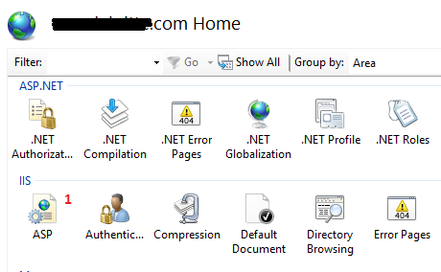](https://i.stack.imgur.com/DOhlU.png)

1. In the option window increase the Response Buffering Limit to 40194304 (approximately 40 MB) .

[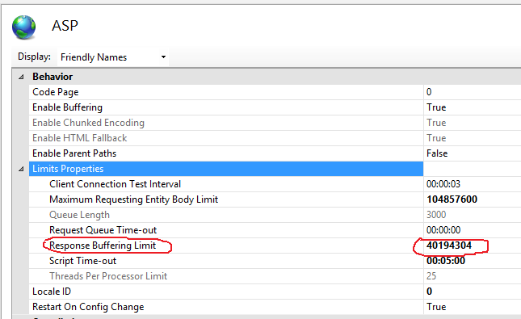](https://i.stack.imgur.com/XK81g.png)

1. Navigate away from the option, in the right hand side top you can see the **Actions** menu, Select **Apply**. It solved my problem.

[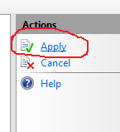](https://i.stack.imgur.com/Dray9.png)